Day in the Life of the Hudson River 10/13/22
Shirley Chisholm State Park, Jamaica Bay
RIVER MILE: -3.75
Salt Front: ~ RM76
Shirley Chisholm State Park– Ciara Scully, NYS Parks
3 adults
Latitude 40° 38’ 12” N & Longitude – 73° 52’ 21” W
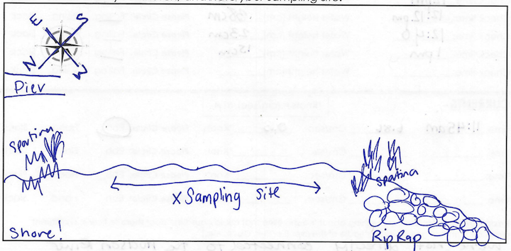
Location: East New York, Brooklyn
Area: A slightly protected part of Jamaica Bay with an open sandy shoreline near marsh grasses.
Surrounding Land Use: Urban/Residential; Beach; Grassland Park
Sampling Site: Beach
Shoreline: 95% Sandy, 5% Rocky
Plants in area: Salt marsh cord grass (Sportina)
River Bottom Description: Sandy
*NR = Not read/recorded
ITEM |  | Time |  | Reading |  |  |  | Comments
Physical
Air Temperature- |  | 11:45 AM |  | 19.4°C |  |  | 67°F
Wind Speed: |  | 11:45 AM |  | Anemometer  13.5 mph |  |  | Beaufort  3 | Direction  SW
Weather today |  | 11:15 AM |  | >75% cloud cover |  |  | Start & Stop Rain
Weather the past 3 days: |  | Very nice day yesterday
Tides- |  | Time |  | Rising, Falling, Unchanged |  |  | Water Height (cm)
 |  | 11:35 AM-1:00 PM |  | Falling |  |  | 50 cm  15 cm
Current- |  | Time |  | Cm/sec |  | Knots | North/South | Ebb/Flood/Still
 |  | 11:45 AM |  | 6.86 |  | NR | NR | Ebb
Water Temperature- |  | 12:31 PM |  | 17°C |  |  | 62.6°F
Turbidity- Long Sight Tube (120 cm) |  | 12:02 PM |  | 110.6 cm
Chemical
Salinity-Refractometer |  | 9:47 AM  11:00 AM |  | 23 ppt  23 ppt  20 ppt
Standardized Salinity – Refractometer |  | 11:15 AM |  | 26,000 ppm
DO – Hach Drop Count Kit |  | Time  12:31 PM |  | Temp  17°C  17°C  17°C |  |  | ppm DO  10 ppm  8 ppm  9 ppm | % saturation  105%  80%  94%
pH – Color Match Kit |  | 12:27 PM |  | 8
Nitrates- NR
Phosphates- NR
Alkalinity- NR
Biological-
Fish – Seine |  | Number |  | Name |  |  | Length of longest | Length of smallest
1:00-1:15 pm |  | 85 |  | Atlantic Silverside |  |  | 10 cm | 3.5 cm
Fish Totals |  | TOTAL: 85 |  | Diversity: 1
Macroinvertebrates |  | Number |  | Name |  |  | Length of longest | Length of smallest
Macroinvertebrate Totals |  | TOTAL: 0 |  | Diversity:0
Sediment Core - NR
Length  NR | H2S smell |  | Oxid Top |  | Oil |  | Grain Size | Other Features
Boats-NA
 | Time |  | Name |  | Color |  | North/Southbound | Light/Loaded
Commercial NR
Recreational NR

